345 loops were selected from GMD.

Sessions with Luis Tabuenca <luistabuencaf@gmail.com>:

1. After the first 2 sessions with Genis and Ignasi, we suspect that the styles of dualisations may vary a lot among participants. We found Luis Tabuenca, a former drummer in residency at Phonos and current artist residence at Fabra i Coats; he could provide 4 hours everyday Mon-Fri in an entire week to do the experiment, so instead of just data collection, we replanned the sessions for Luis, starting with a repetition ‘pilot’ session, and deciding what the experiments could be after the ‘pilot’ session.



1. Pilot Test (3Hours): We selected 72 2-bar loops and repeated them 3 times and randomized their order and asked Luis to dualize them.   
     
   We did not tell Luis about the repetitions → After the experiment Luis noted that he did notice that there were repetitions.
2. Luis said that he can provide us with two versions of the dualizations: a simple dualization vs a more complex one. As a result we decided to test the remaining examples twice, once asking for a simple dualization and the second time asking for a more complex one. For part two, we tested the remaining loops (345-72=273). However, this time we only asked for two repetitions.   
     
   To do so we, prepared 4 session (A, B, C, D) for each which we selected 68 loops. In each session, we first presented the 68 loops (A1, B1, C1, D1) and asked for a simple dualization. While, in the second run of the session (A2, B2, C2, D2) we used the same 68 loops as the first half and asked for a more complex dualizations

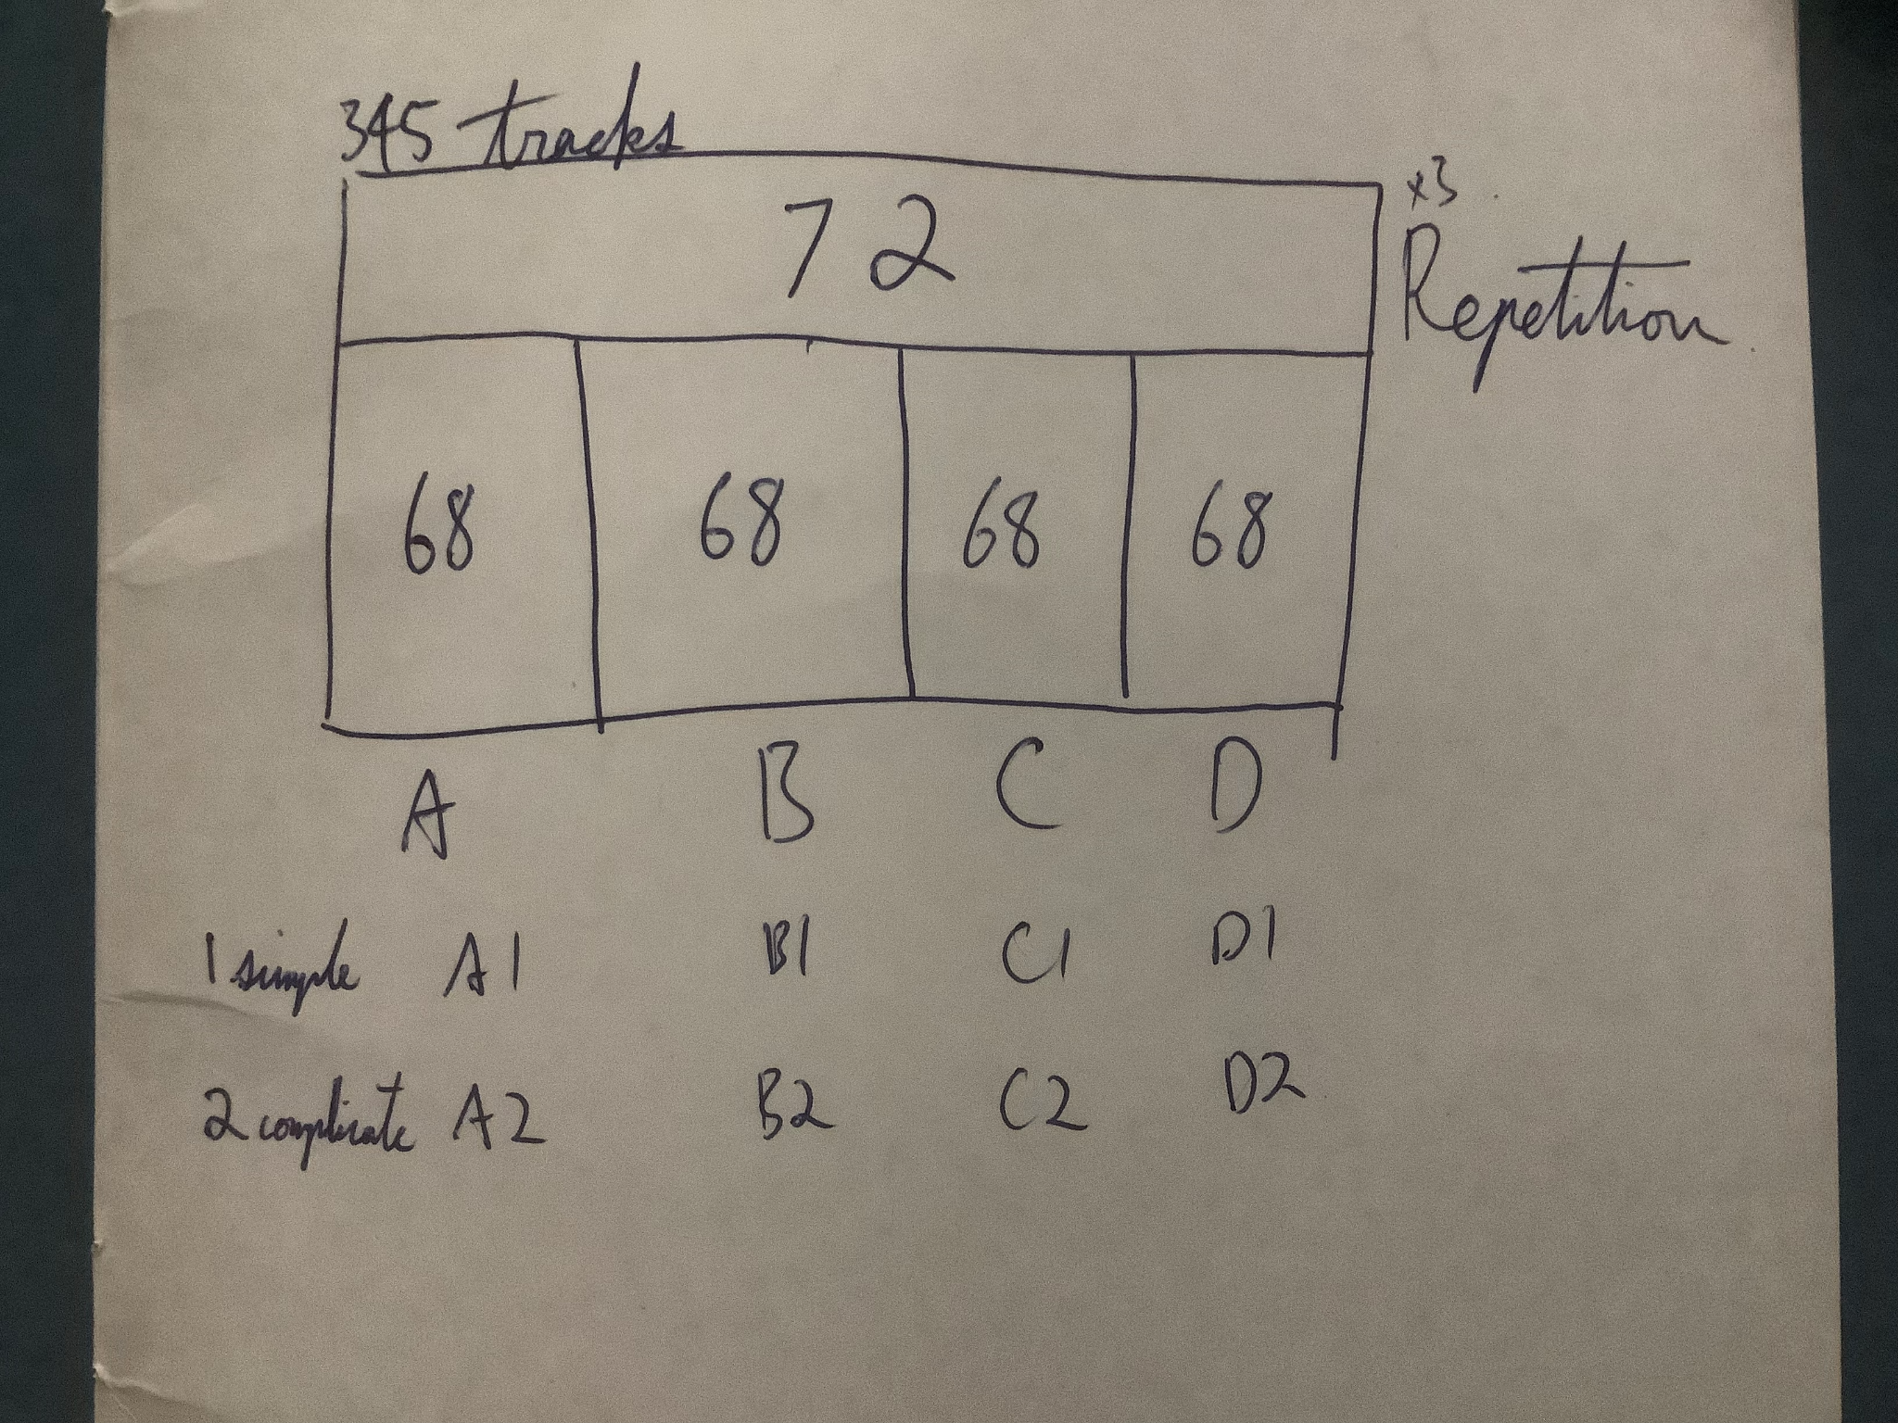

Sessions with other participants:

5 individual drummers, 8 hours more:

1. 2 data collection sessions (1 hour each) in the beginning with each 72 randomised tracks from the 345 tracks. We found out the styles of dualisations may vary a lot among participants, so we redesigned the experiment and focused on repetitions.
2. 4 repetition sessions (1 hour each) with individual drummers. 24 tracks extracted from Luis’ repetition session with a balanced selection of genre. Each track repeated 3 times and randomised.
3. 2 sessions with Pau, doing A1, A2 with the simple/complex dualisations.



Tasks to be done before meeting with Sergi Next week:

1. Finalize the exports (processing) the collected data
2. Create excel documents of the questionnaires

<https://docs.google.com/spreadsheets/d/1J06IoxUv9V7FKr4wQRIS0VmEttcDq3Q5Vlyh3DQXzvw/edit?usp=sharing>

1. Update the log above
2. Make sure you translate the interviews

<https://docs.google.com/document/d/1OCOU_vekYhSrodnIcaJwtoqkb7IF3M-aX4z7przGl4A/edit?usp=sharing>

**PRESENTATION STUFF**

3 Main Questions:

## Q1. Does dualization exist? Is this a doable/meaningful task

Use interviews / questionnaires

## Q2. Is there correlation between dualisations of the **same** drummer?

If we ask a drummer to dualize a pattern multiple times at random, how consistent will these dualizations be? (Intra-drummer consistency of dualizations)

Compare results computationally

* Cosine distance
* Distances from Daniel’s paper
* Other distances like Hamming?

Predictions from the drummers in interviews (Views on what they think they did with different repetitions)

## Q3. Is there correlation between dualisations of the **different** drummer

If a single pattern is given to multiple drummers for dualization, how consistent will these dualizations be? (Inter-drummer consistency of dualizations)

* Look at histogram of responses rather than the averages
* Agreement indices for inter-drummer distance analysis (for 123 representation for example) → Maybe we should ask Juan Gomez
* huffman coding
* <https://en.wikipedia.org/wiki/Jaccard_index>
* Slide 41→ use distance rather than correlation
* Focus on describing the data rather than prooving/disproving a hypothesis
* Check and see to what extent velocity is used for encoding information (use simple /complex variation of velocity ) → compute stdev of velocity of each pattern and each drummer
* We should also look at the evolution of dualizations for a given pattern
* Influence of orchestration

Levenshtein Distance

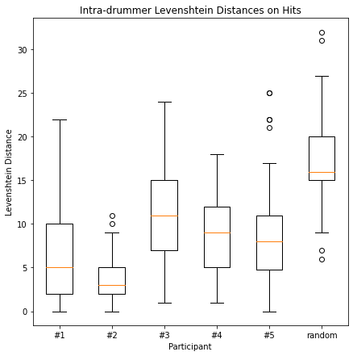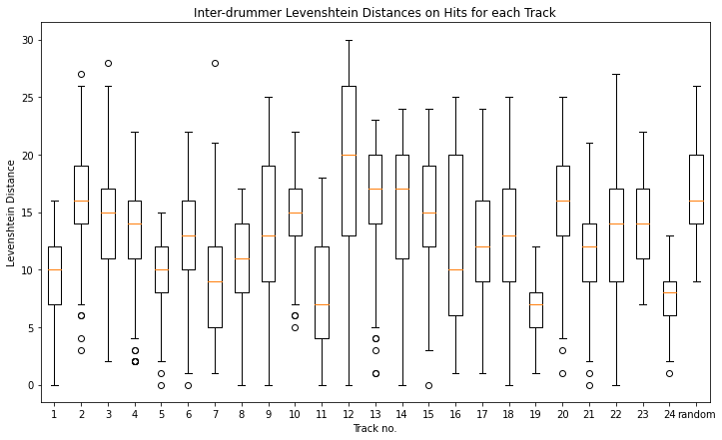

* Jaccard Distance on matrix or list
  + Krippendorff's alpha and Spearman’s Rank also
* Add metrical weight profile (rhythmic syncopation awareness)